

**SNAG@JOB**

CS551 ASE Project Increment4 Report



May 1, 2015

UNIVERSITY OF MISSOURI-KANSAS CITY

CS551 ASE Project SPRING 2015

By

Srikar Reddy Mallareddygari-ID#33

Surekha Dani-ID#12

Lavanya Kumar Somu-ID#46

Sandesh Puppala-ID#42

Table of Contents

Import Existing Services/API 3

Detail Design of Services 5

User Stories /Use Case (Using Scrum Do) 5

Scrum Board: 5

Service description 8

Activity Diagram 10

Class diagram 12

Class Diagram Description 13

Design of Mobile Client Interface 13

Implementation 14

Implementation of REST services 14

Implementation of user interface (Mobile Apps) 22

Android Studio Activities 22

Implementation of test cases 22

Testing 23

Functional Testing 23

Test of Web Service using NUNIT 23

Deployment Testing 26

Test of Web Service using WAPT 26

Test of Android App using Systrace 28

Deployment 29

Scrum Do Link 29

Summary 29

https://www.scrumdo.com/projects/project/snagjob1/summary 29

Iteration4 29

GitHub Link 29

Source Code 29

Documentation 29

Report 30

Android Activity Screen Layouts 30

Project Management 38

Work completed in Current Iteration 38

Description 38

Responsibility (Task, Person) 39

Time taken 39

Contributions (members/percentage) 39

Issues/Concerns 39

# Import Existing Services/API

**Screenshots for Google API integration**

* OAuth Access Application Access for Google+ Sign In

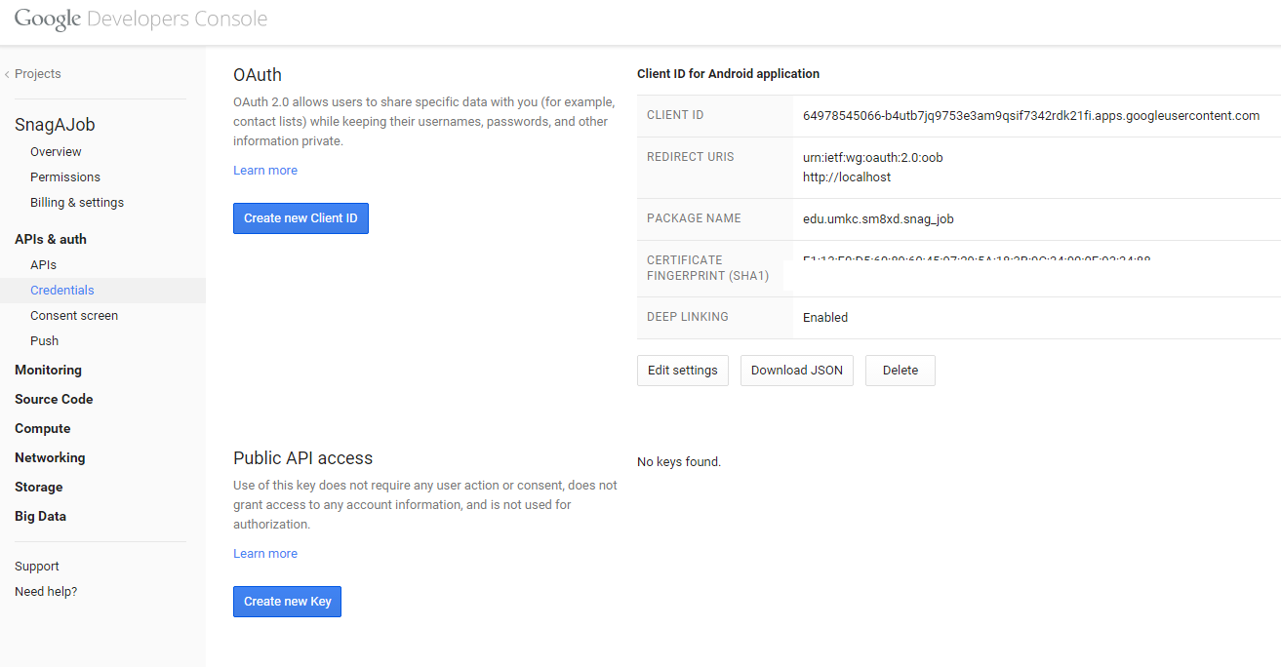

* Google Sign In Validation for Mobile App

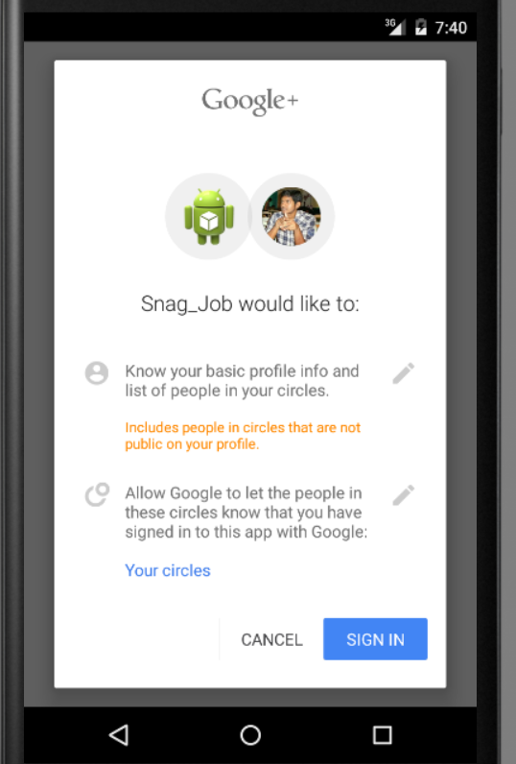

Screenshots of LinkedIn Sign In Integration

* App Registration

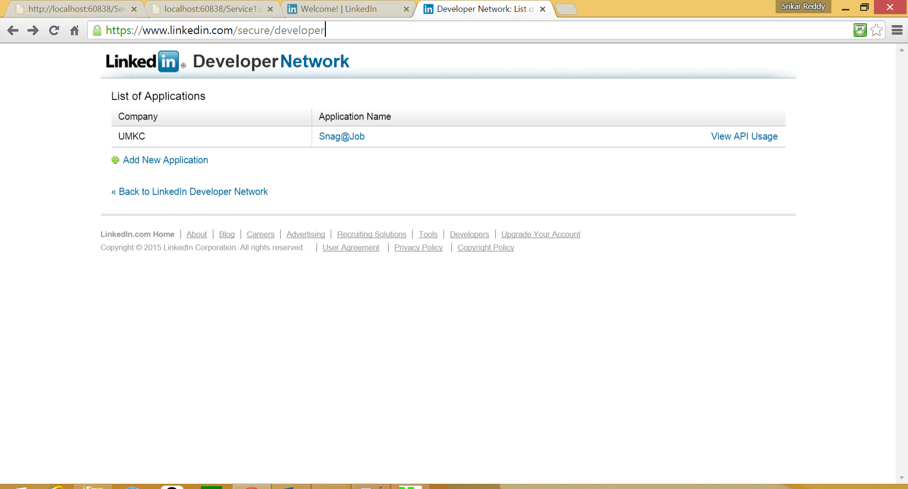

* User Sign In using LinkedIn

Login Implementation of LinkedIn

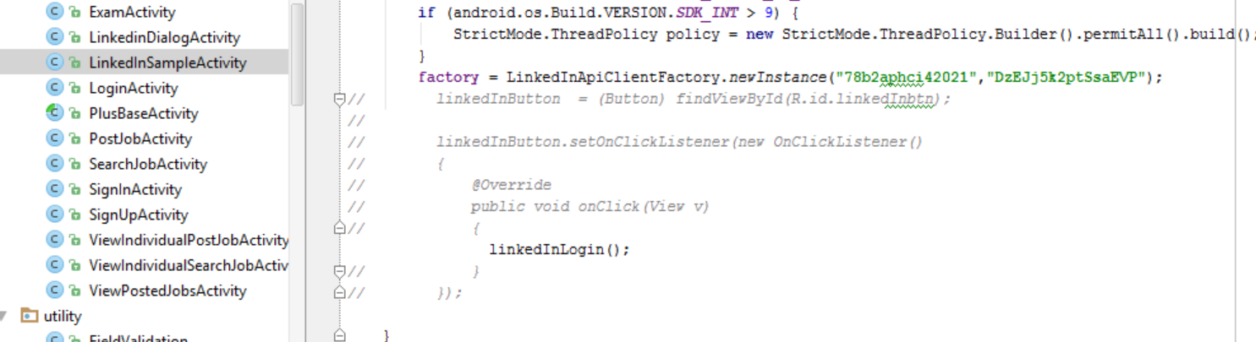

Sign In Screen Using LinkedIn

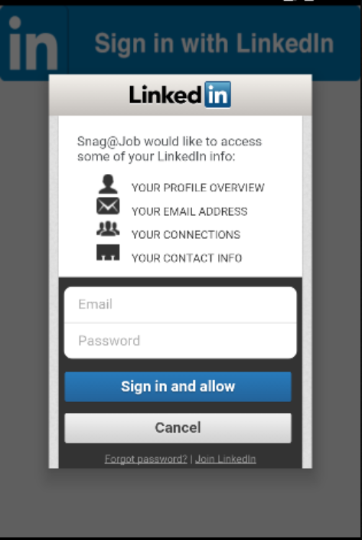

# Detail Design of Services

## User Stories /Use Case (Using Scrum Do)

## Scrum Board:

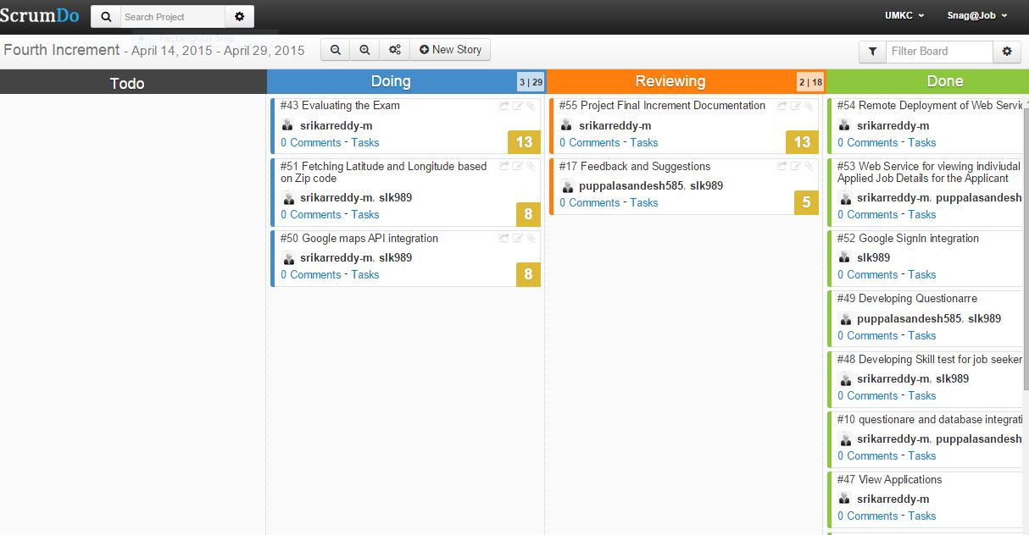

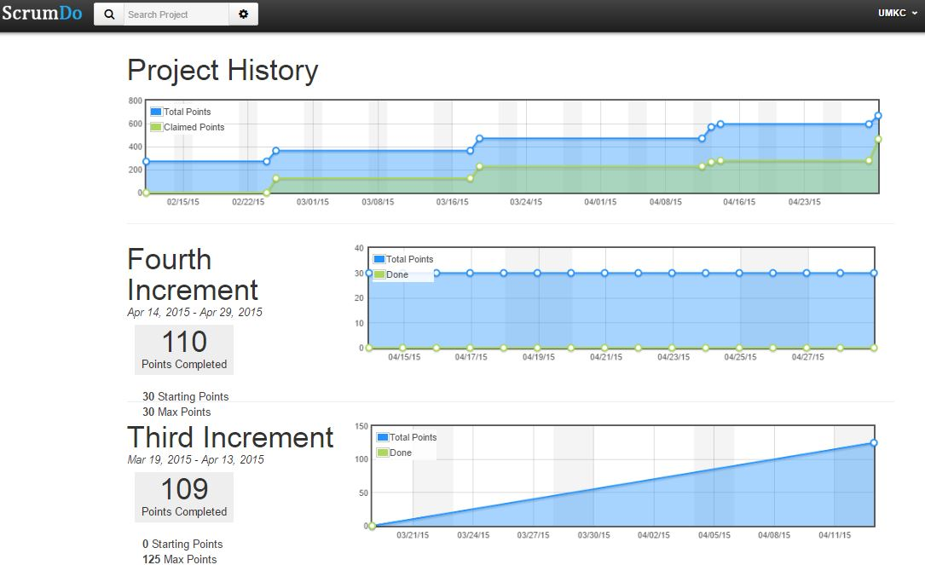

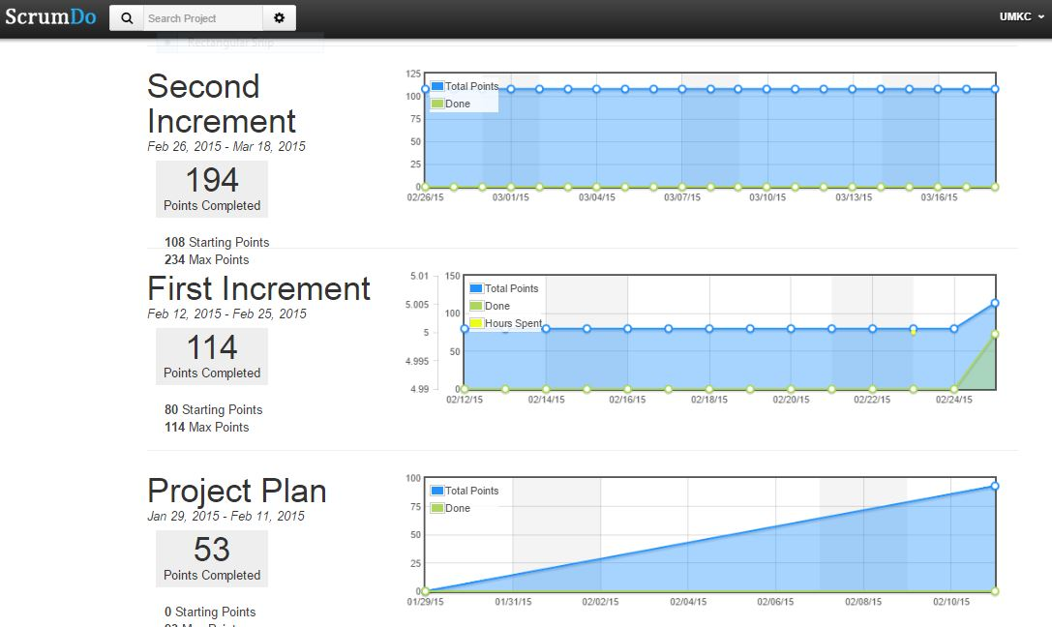

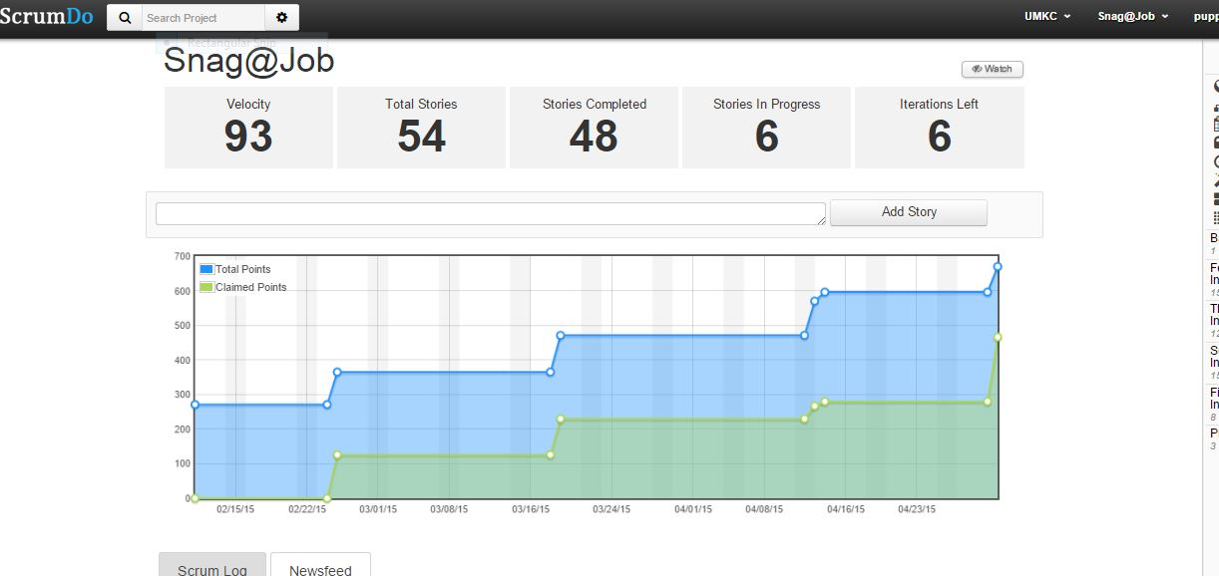

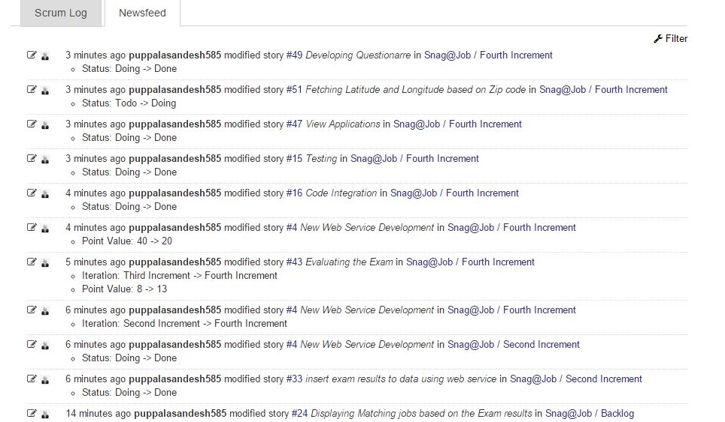

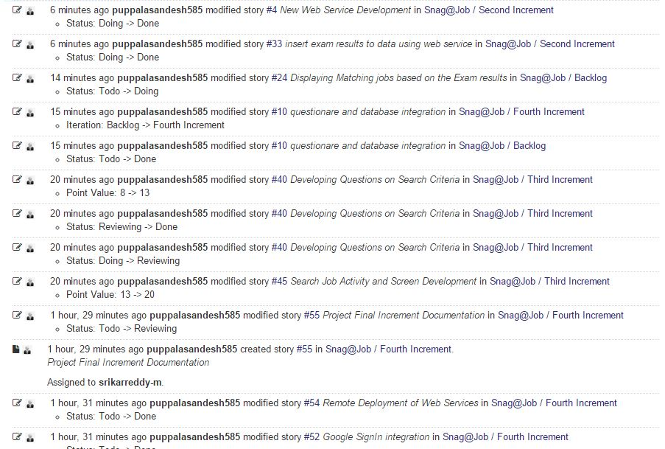

## Service description

* **Snag job Web service:** The following Web services are used by **Snag@Job** Application and they are designed in Microsoft Visual Studio. It consists of the following URI Templates
  + - **insertUserDetails**
    - **retrieveUserDetails**
    - **insertJobDetails**
    - **retrieveJobDetails**
    - **retrieveIndividualJobDetails**
    - **jobSearchDetail**
    - **updatePostJobDetail**
    - **jobApplication**
    - **individualJobApplication**
    - **retrieveQuestions**
    - **retrieveAppliedJobDetails**
    - **retrieveApplicationJobDetails**

Brief description about the above URI templates are

***insertUserDetails****:* This method performs storing of the user profile details to the MySQL server 2008 database.

***retrieveUserDetails:*** This method is useful to retrieve the user profile details after successful validation of login credentials.

***insertJobDetails:*** This method is useful to insert the job details in to the MySQL server.

***retrieveJobDetails:*** This method is useful to retrieve the job details based on the search criteria.

***retrieveIndividualJobDetails:*** This method is used to fetch the data related to a particular jobs posted by Employer.

***jobSearchDetail****:* This method is used to fetch the job details based on the search criteria provided by the applicant.

***updatePostJobDetail:*** This method is used if the Employer tries to modify the posted job application.

***jobApplication:***This method is used to fetch the list of applicants who have applied to a particular job. It is used by the Employer to view job applications.

**individualJobApplication:** This method is used to fetch the information about the applicant who has applied to a particular job. It is used by the Employer to process the application i.e. to accept/reject the application

**retrieveQuestions:** This method is used to fetch the questions from the database. When an Applicant applies to a job he/she is asked to give an exam to test their skills.

**retrieveAppliedJobDetails:** This method is used to fetch the list of jobs that an applicant has applied. It is used by the Applicant to check the status application i.e. to accept/reject.

**retrieveApplicationJobDetails:** This method is used by the applicant to view the individual job details that he has applied. The applicant can check the status of the application.

**Sending Email to Applicant:**

An Employer can either accept or reject the applications and while doing so he can send an email to the applicant specifying the status of the application. This is achieved by selecting an email client installed in the phone.

## Activity Diagram

1. **Employer**

The Employer can post a new job or edit an existing posted job. He can also view the list of applications and accept/reject the application based on the score.

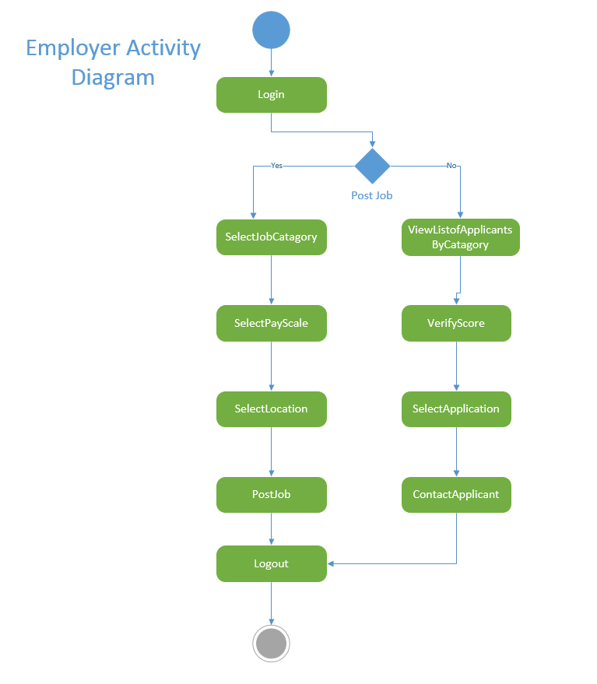

1. **Applicant**:

The applicant can search for a job based on the Category, Sub Category, Job location and pay scale and he can apply for the job. In order to test his knowledge he has to give an exam while applying for the job which tests his skills for the selected job category. The applicant can also check the status of his application by logging into the app. The employer will send an email to the applicant once his application is accepted or rejected.

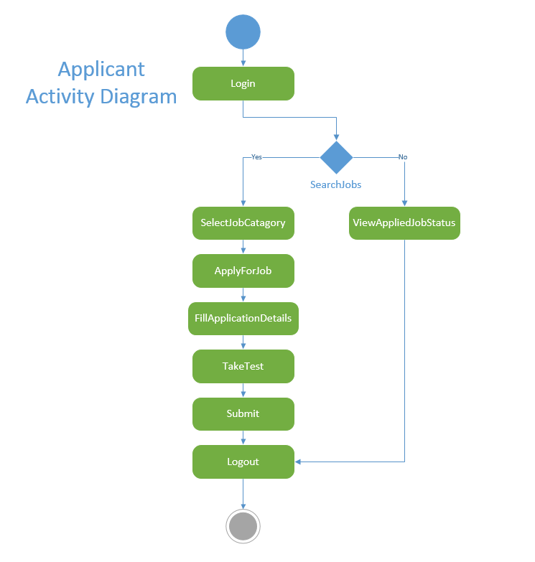

A Web service named Snag_Job is developed to perform a user’s registration and retrieval of the users profile data.

* When a user tries to Sign up in to the mobile application, the user details will be stored in to the MySQL DB using a Web service call.

<http://localhost:60838/Service1.svc/insertUserDetails/>

* When user tries to login in to the application, User credentials are authenticated through a Web service call. For authenticated users corresponding profile data will be displayed to the presentation layer of the mobile application.
* When employer logins into the app, he can post the jobdetails for a particular job.This is accomplished by call the insertJobDetails web service.

[**http://kc-sce-cs551.kc.umkc.edu/aspnet_client/Group5/project/Snag_Job/Service1.svc/insertUserDetails/**](http://kc-sce-cs551.kc.umkc.edu/aspnet_client/Group5/project/Snag_Job/Service1.svc/insertUserDetails/)

* When applicant logins into the app and tries to apply for any job,the list available jobs are retrieved from the database by calling the retrieveJobDetails service

[[**http://kc-sce-cs551.kc.umkc.edu/aspnet_client/Group5/project/Snag_Job/Service1.svc/insertUserDetails/**](http://kc-sce-cs551.kc.umkc.edu/aspnet_client/Group5/project/Snag_Job/Service1.svc/insertUserDetails/)](http://localhost:60838/Service1.svc/retrievelogin/dani)

## Class diagram

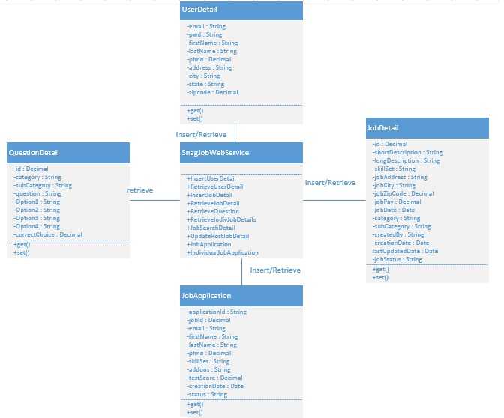

## Class Diagram Description

* As shown in the above class diagram, we have implemented four different classes namely UserDetails, JobDetails, JobApplications,QuestionDetail, SnagJobService.
* UserDetails class consists of various fields like first Name, last Name, phone, address, state, city and zip code along with their getter and setter methods.
* JobDetails class consists fields jobId,jobCategory,jobSubCategory,etc. along with setter and getter methods. This class is responsible for storing and retrieving of the posted jobs
* JobApplications class consists fields applicationId ,applicant details,etc. along with setter and getter methods. This class is responsible for storing and retrieving of the job applications for both employer and applicant.
* SnagJobService class contains methods for accessing all the web services required for the application.

# Design of Mobile Client Interface

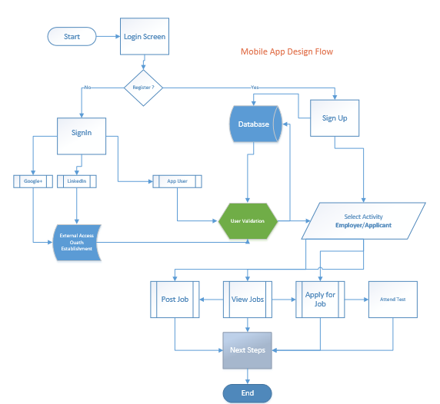

# Implementation

## Implementation of REST services

* Web Service definition for insertuserdetails :

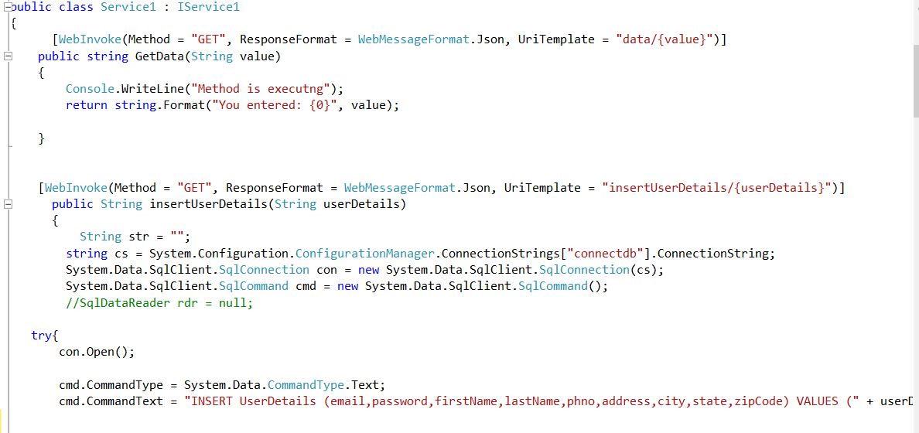

* Web Service definition for retrieveuserdetails

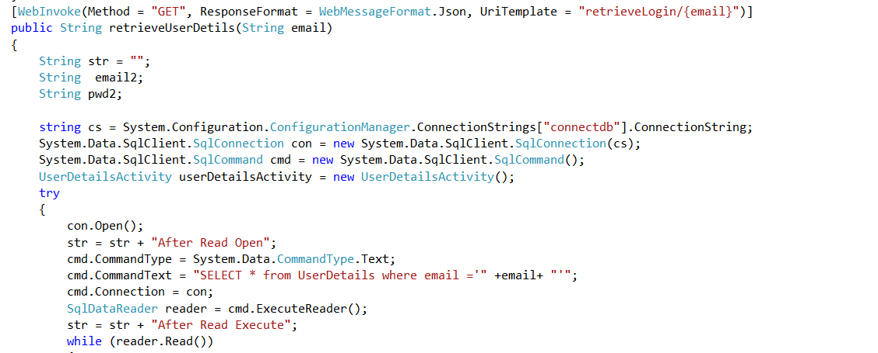

* Web Service definition for insertjobdetails

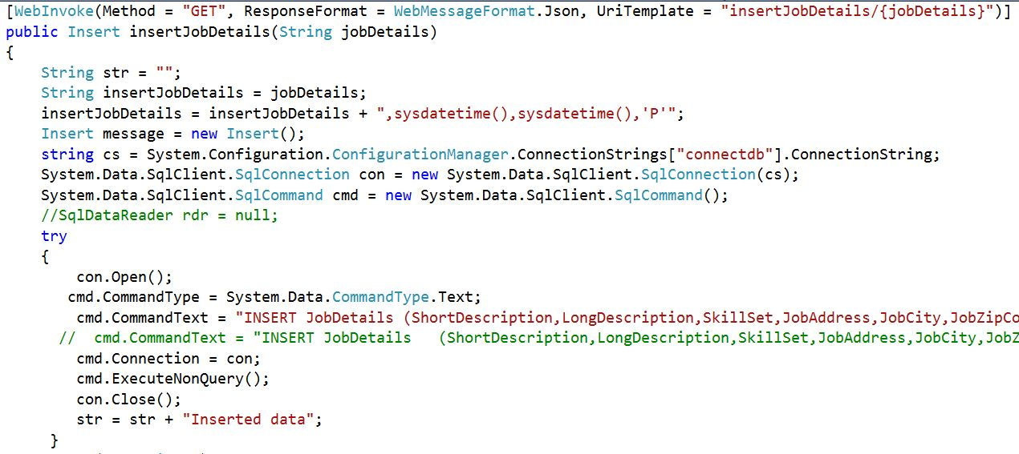

* Web Service definition for retrievejobdetails

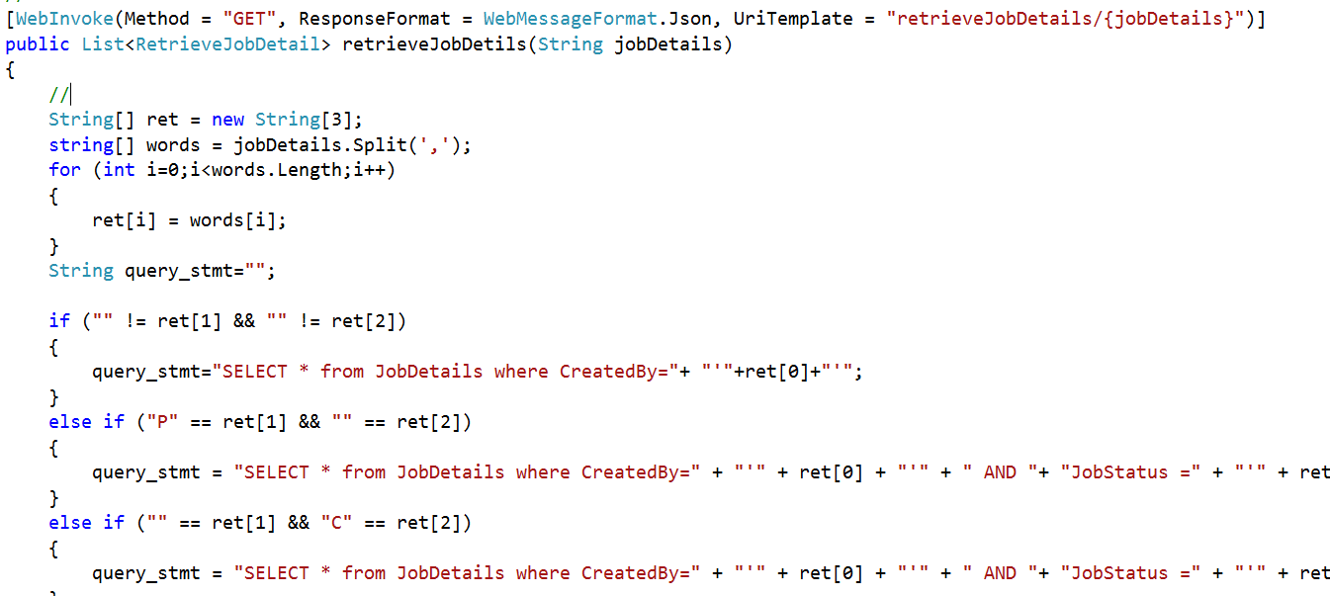

* Web Service definition for retrieveIndividualJobDetails

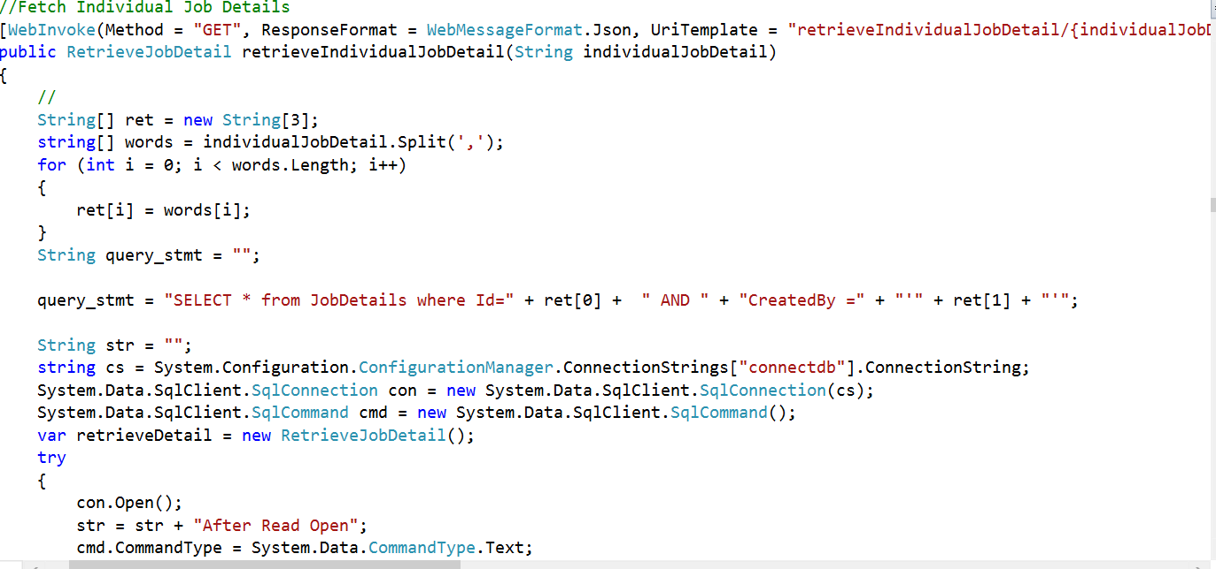

* Web Service definition for jobSearchDetail

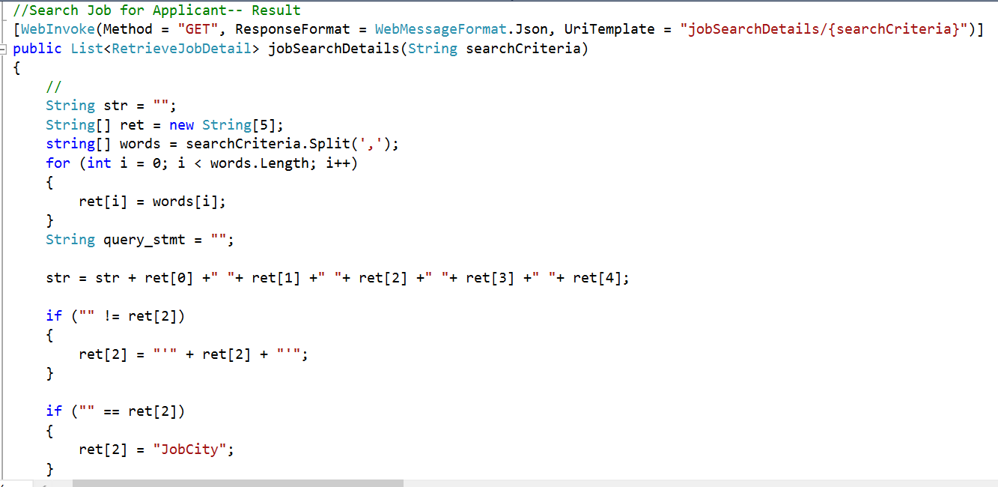

* Web Service definition for updatePostJobDetail

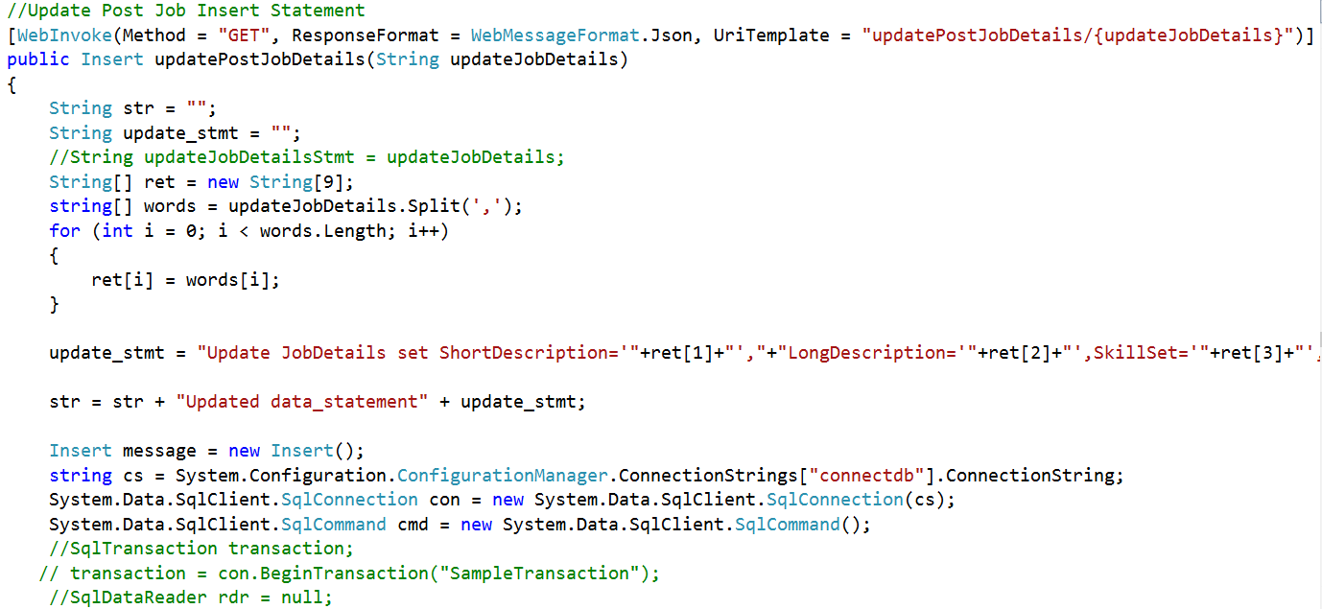

* Web Service definition for jobApplication

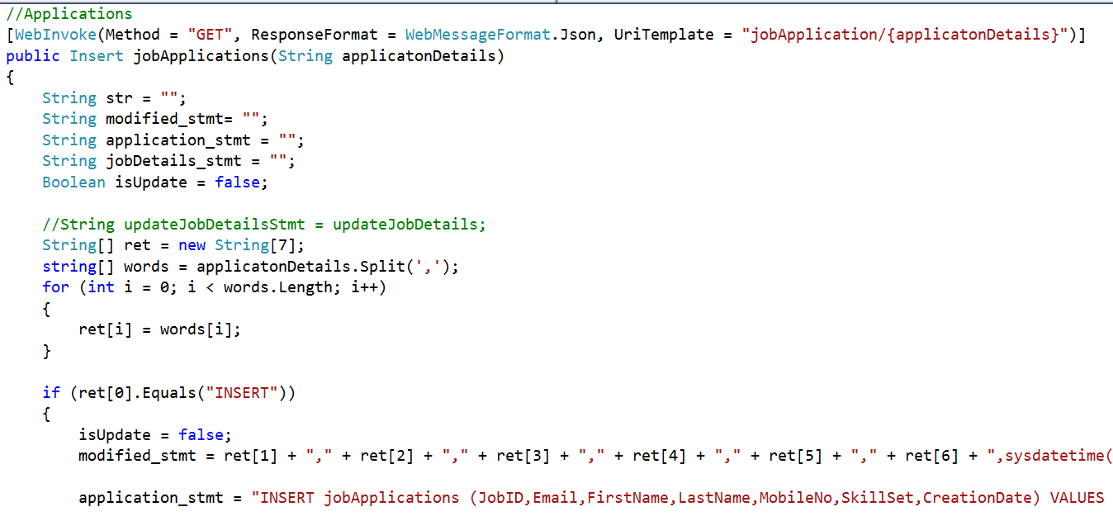

* Web Service definition for individualJobApplication

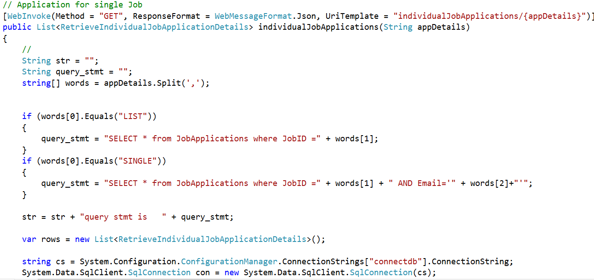

* Web Service definition for retrieveQuestions

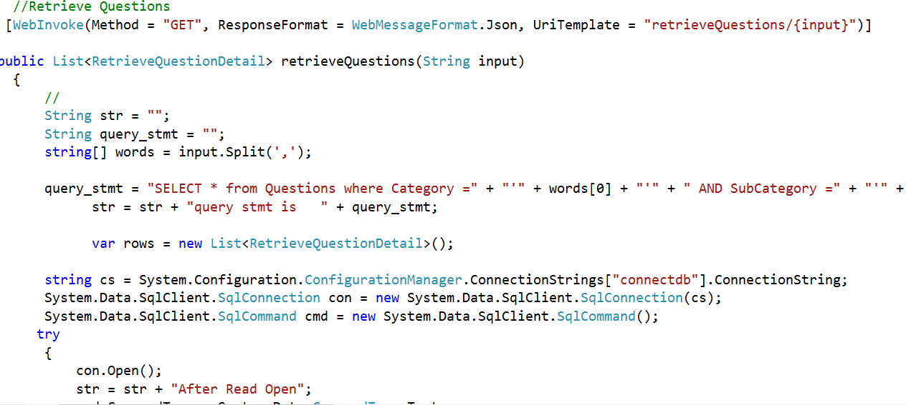

* Web Service definition for retrieveAppliedJobDetails

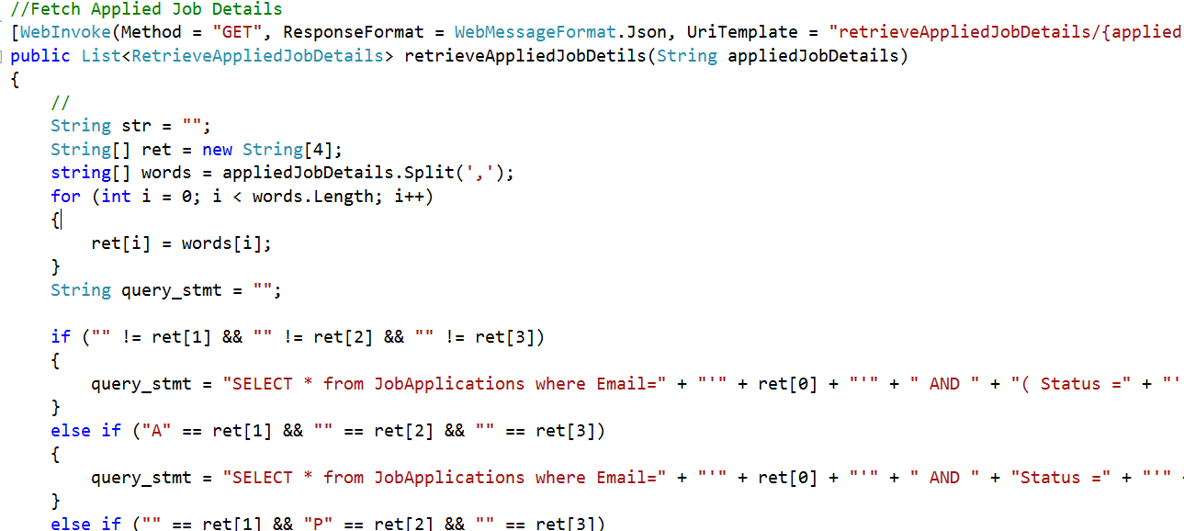

* Web Service definition for retrieveApplicationJobDetails

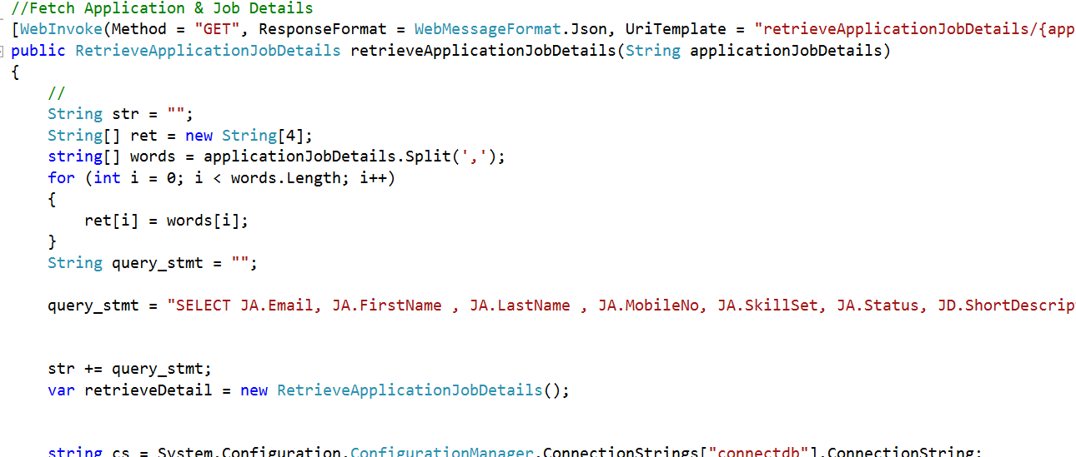

* Database Table Data Definition
  + User Details Table:

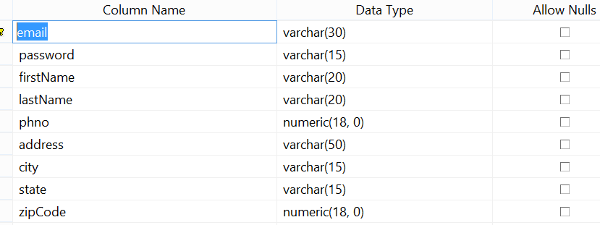

* + Job Details Table:

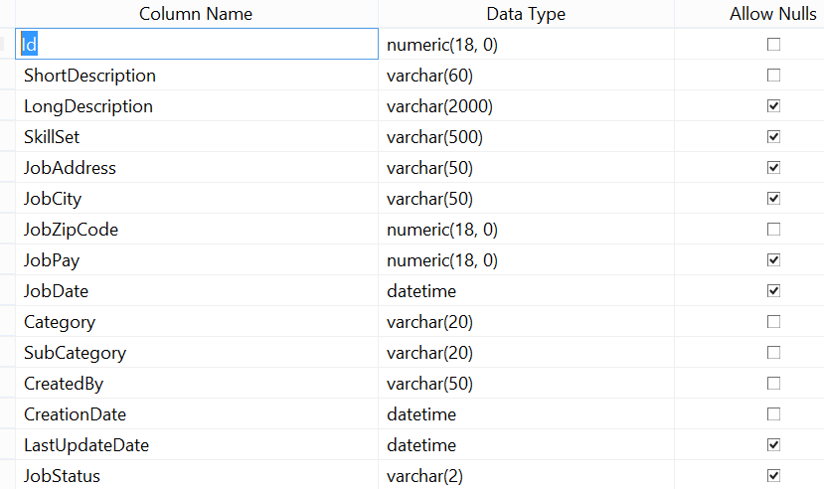

* + Job Applications Table:

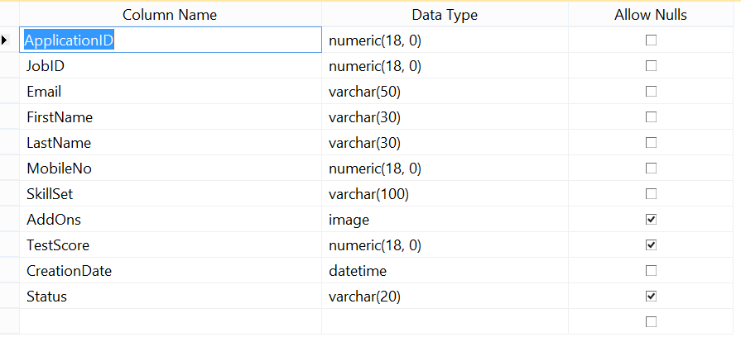

* + Questions Table:

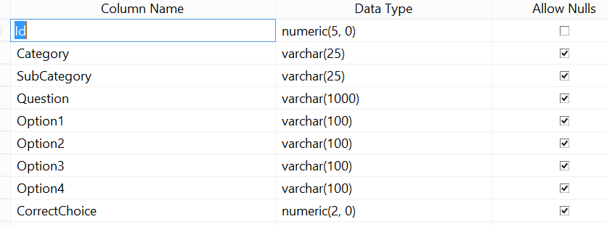

## Implementation of user interface (Mobile Apps)

### Android Studio Activities

Please find the source code of each android activity from the Git hub URL.

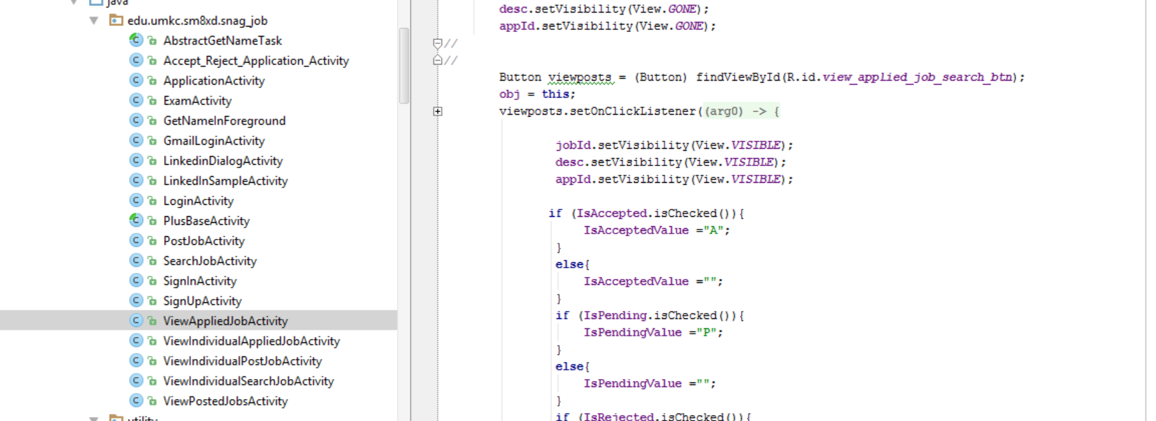

## Implementation of test cases

Please find the below screenshot of NUNIT testing class library.

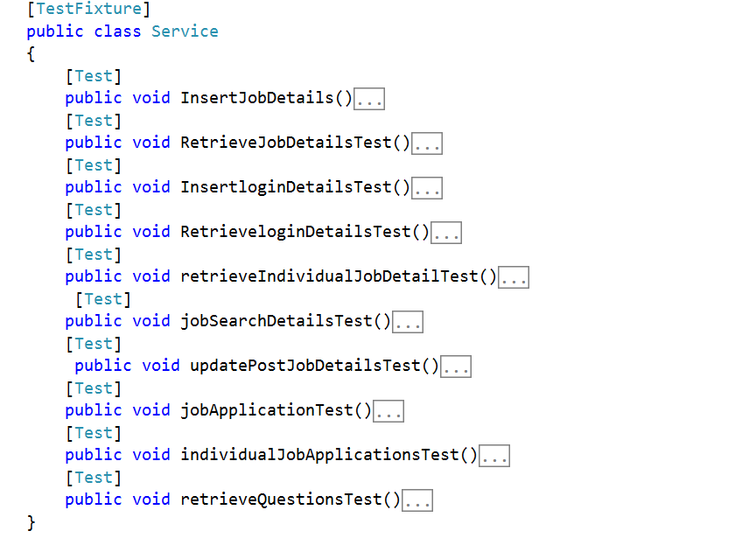

# Testing

## Functional Testing

### Test of Web Service using NUNIT

Testing Class Library for Snag Job Web Service using **NUNIT**

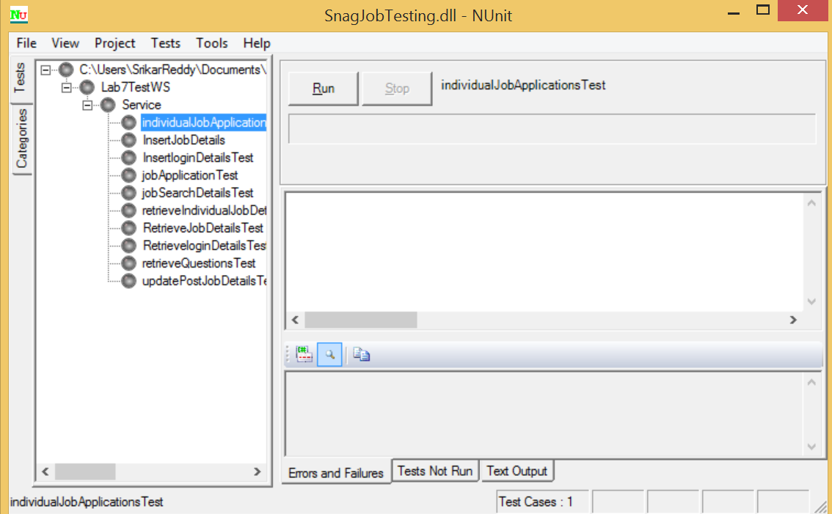

InsertJobDetails()

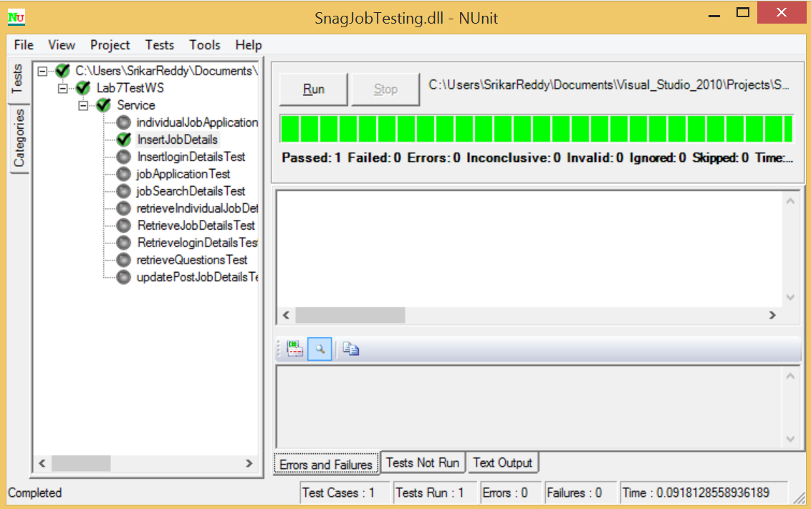

RetrieveloginDetailsTest()

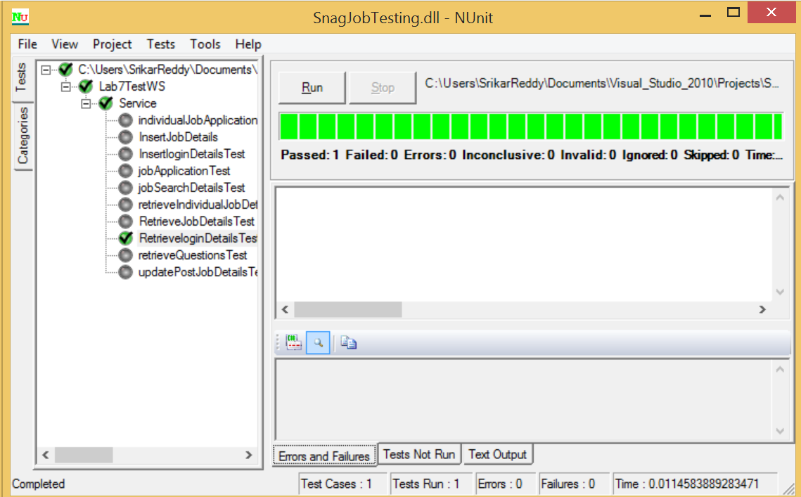

updatePostJobDetailsTest()

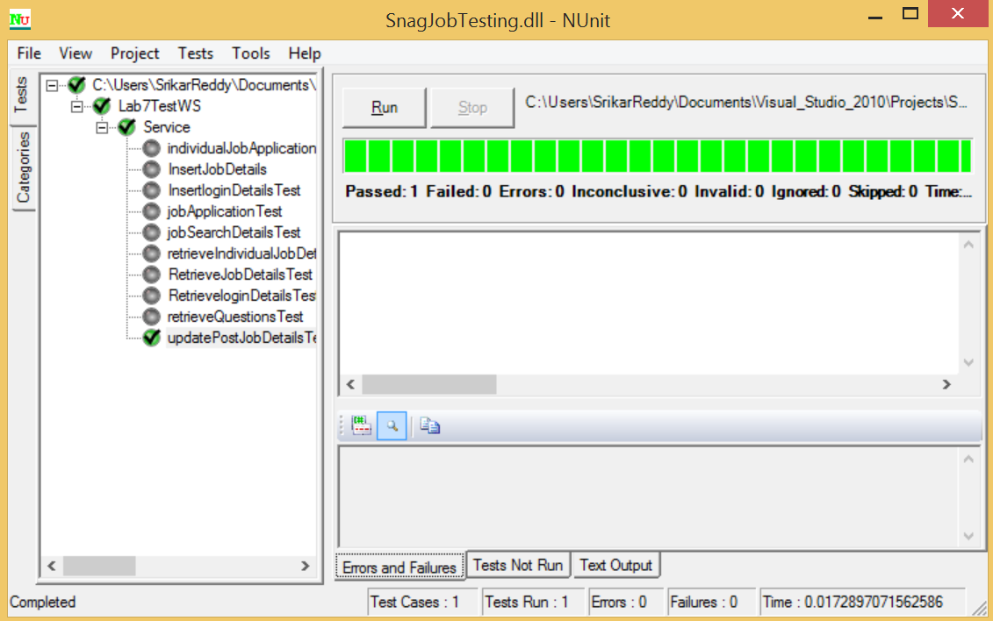

jobApplicationTest()

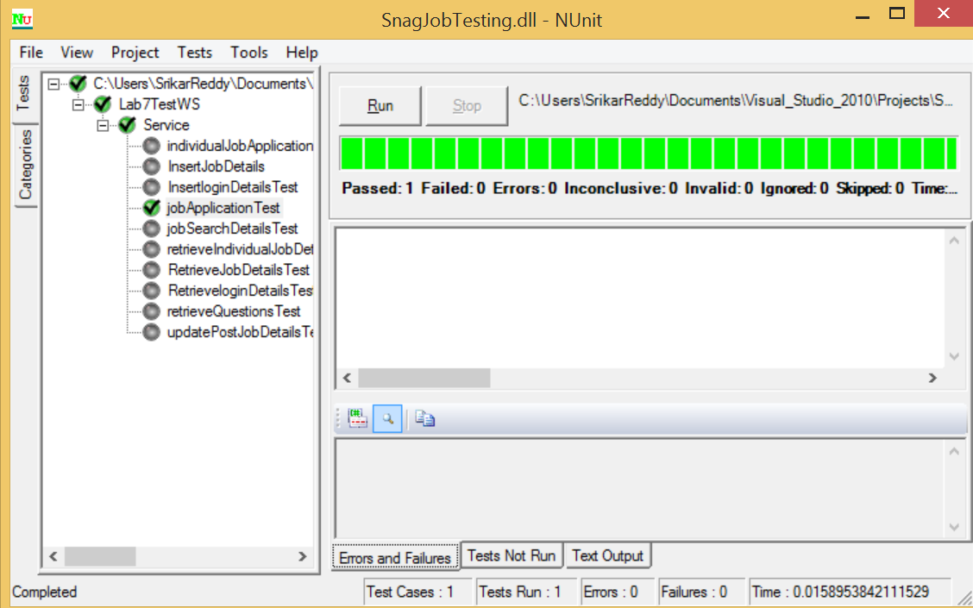

individualJobApplicationsTest()

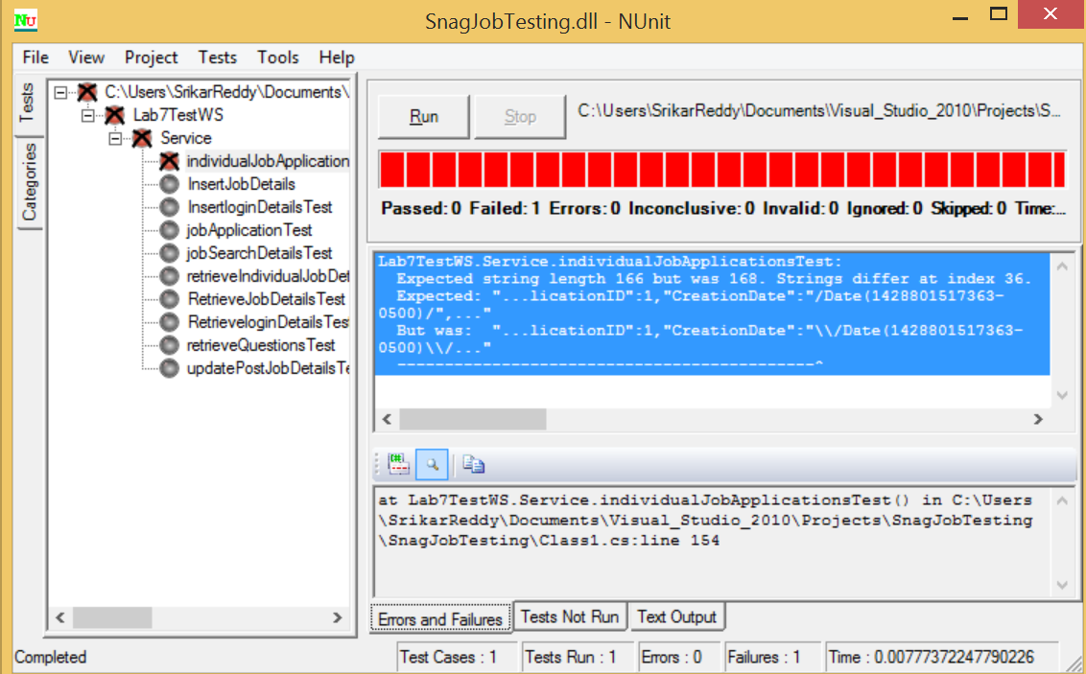

retrieveQuestionsTest()

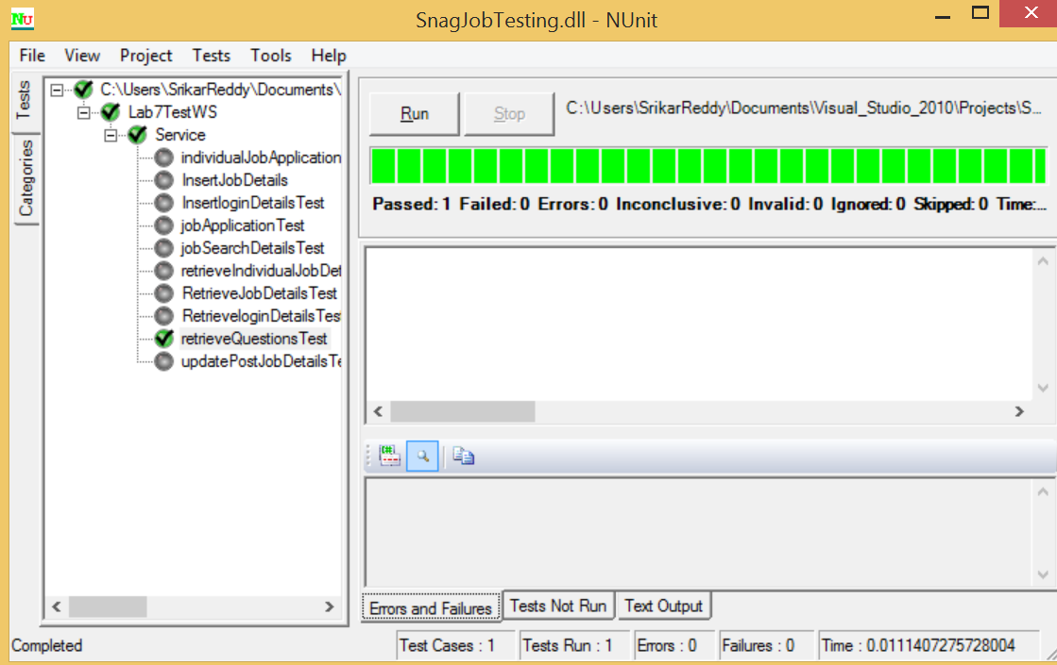

## Deployment Testing

### Test of Web Service using WAPT

WAPT: It is used to perform Load, Stress and performance testing on our web services.

**Why WAPT?**

The WAPT (Website Performs under Load) tool is useful for Load, Stress and Performance testing. This tool is predominantly useful for websites testing only. But unlike any other testing tool this tool is capable of testing the Web service urls.We would like to mention that the tools which were recommended to us for performance testing in the project increment 3 document are only useful for web applications but not android applications. Dreams Park is professional version. But the performance and load testing option is available only in Microsoft visual studio ultimate version. Due the above mentioned constraints we have considered WAPT tool for our project to perform Load, Stress and performance testing on out web service urls.

**Stress Testing on**: retrievelogin web service

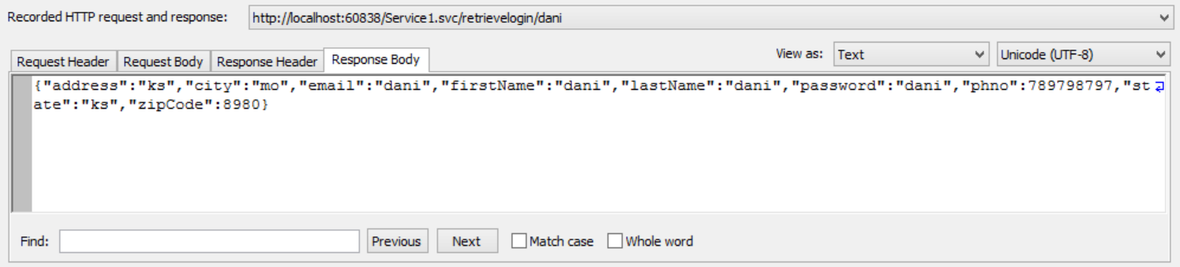

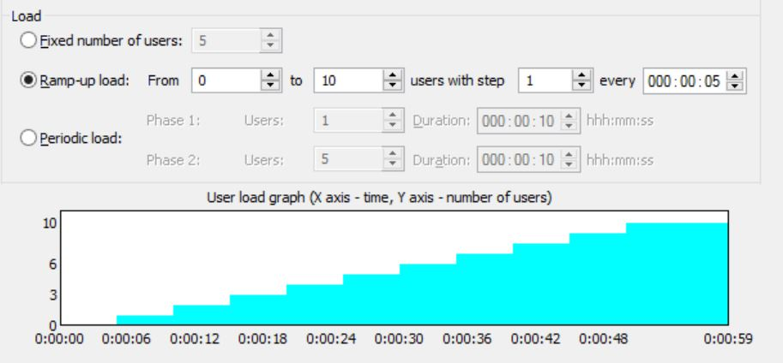

To perform stress testing on the given application we will be ramping up the load step by step after an interval of time by increasing the virtual users count who hits the application. **This testing is useful to test the applications ability to respond to an excessive load.**

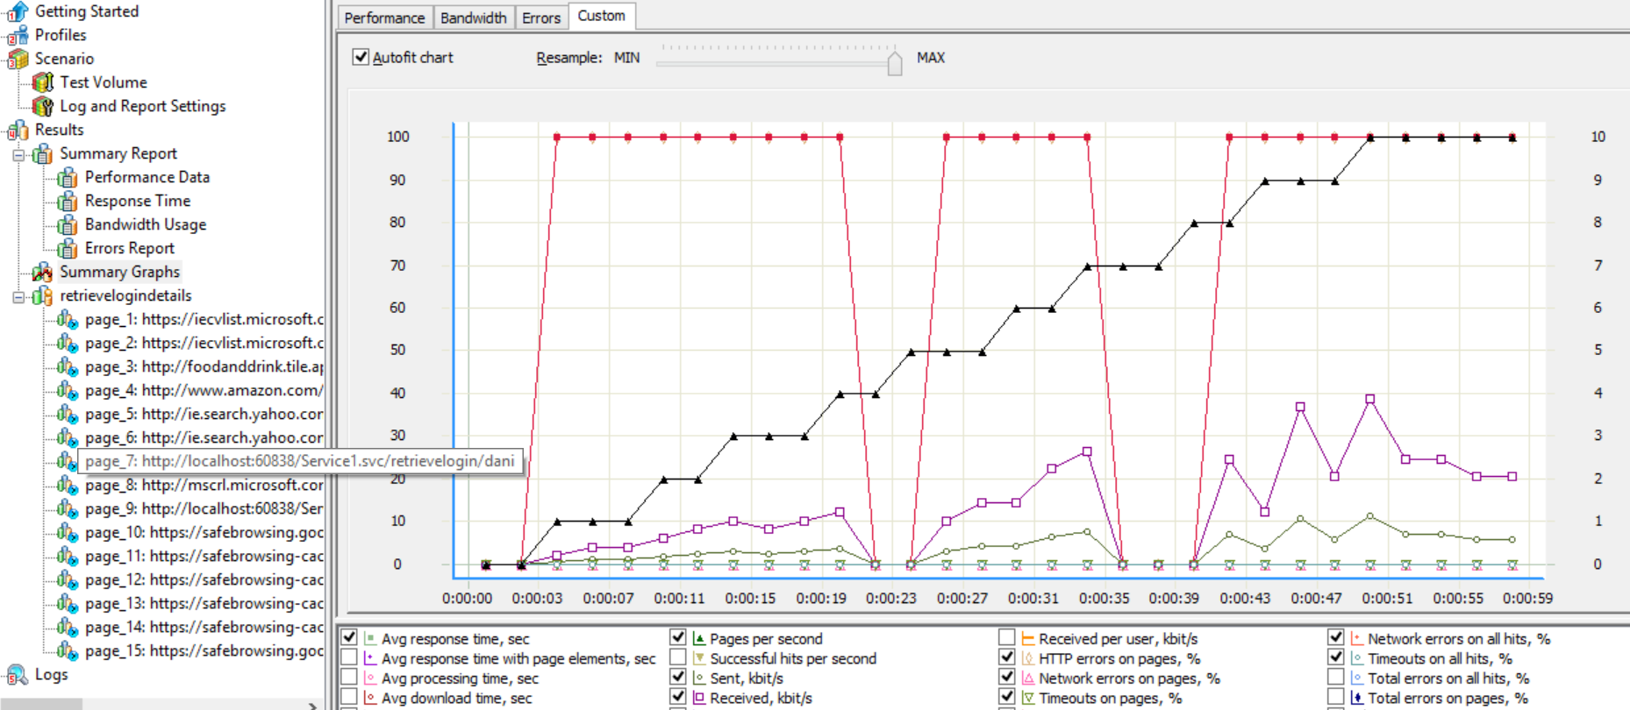

**Endurance testing** on: Jobsearchdetails web service

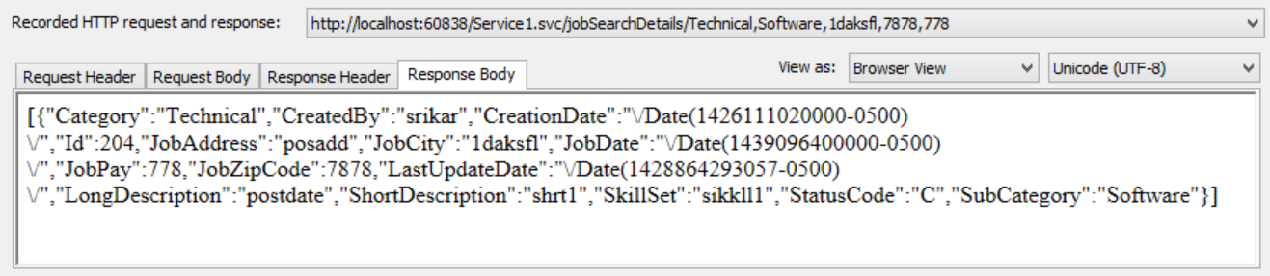 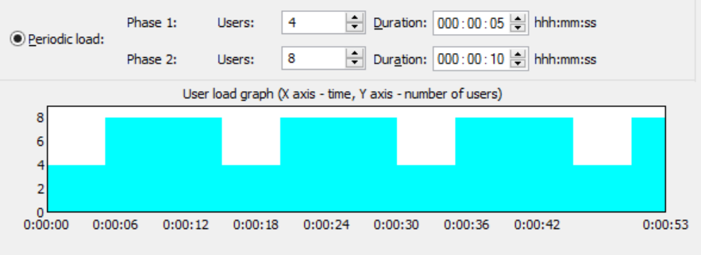

In Endurance testing we will be varying the load periodically on the application. That’s why the name is given as periodic load. During the phase 1 we access the application by 4 different virtual users over a time period of 5 sec. After that we hit the application by 8 different virtual users over a period of 10 seconds. This cycle is repeated over a period of time. **The goal of this testing is that the application performance don’t degrade significantly during different testing phases.**

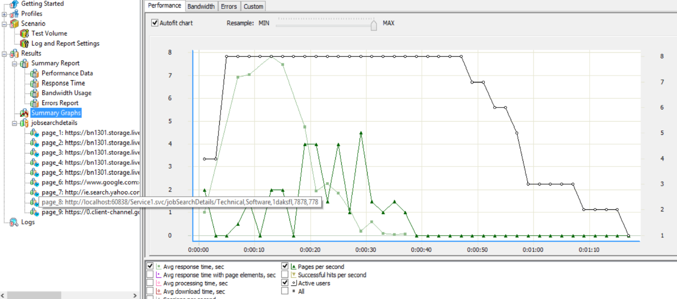

### Test of Android App using Systrace

Why Systrace?

This is a built in tool offered in the Android studio. We are able to generate the device trace for a given period of time and analyzed the graphical output properly. We find out that all of our android screens are displaying properly with no time delay.

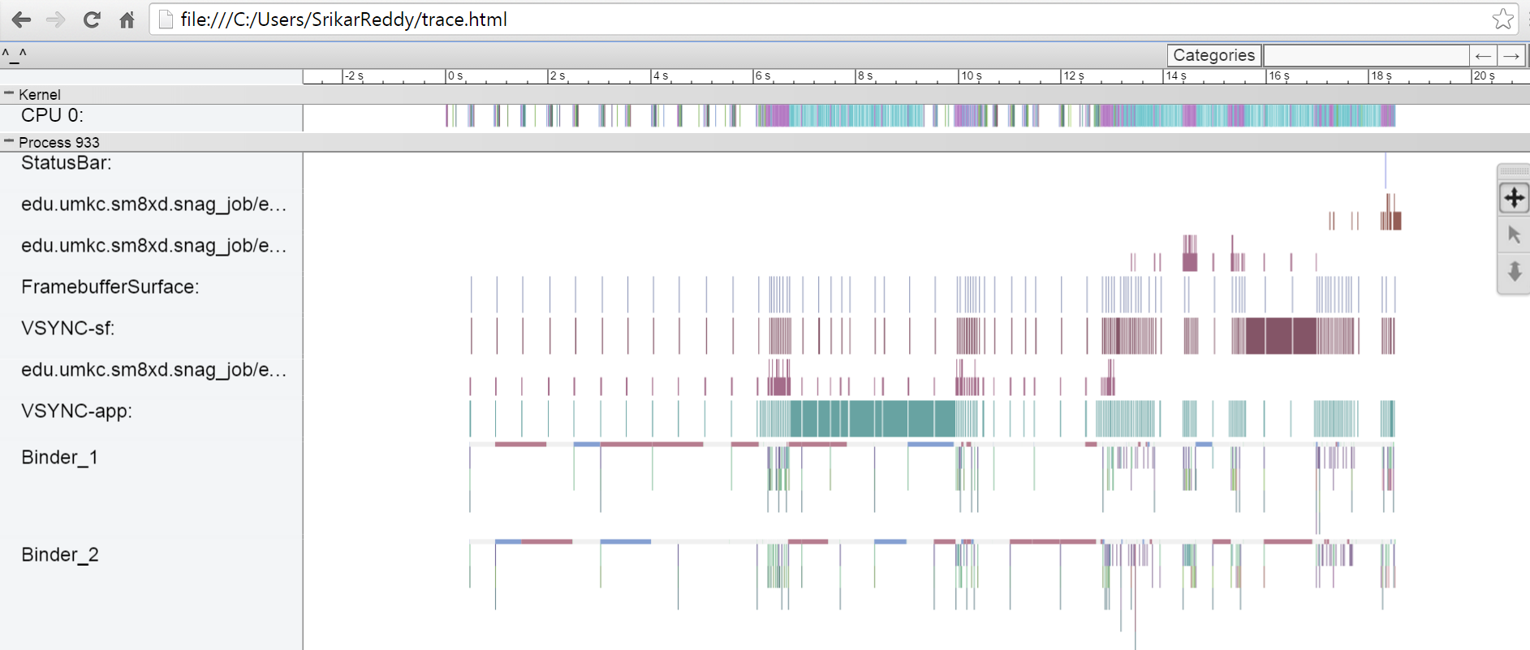

Deployment

## Scrum Do Link

### Summary

### <https://www.scrumdo.com/projects/project/snagjob1/summary>

### Iteration4

<https://www.scrumdo.com/projects/project/snagjob1/iteration/121722>

## GitHub Link

### Source Code

<https://github.com/srikarreddy-m/CS551-ASE/tree/src/Project/Snag%40Job/src/Iteration4/Snag_Job>

### Documentation

<https://github.com/srikarreddy-m/CS551-ASE/tree/src/Project/Snag%40Job/documentation>

# Report

## Android Activity Screen Layouts

**Login Screen:**

A registered user can login with valid email and password. A new user can either register/signup or can login using Gmail account or LinkedIn account.

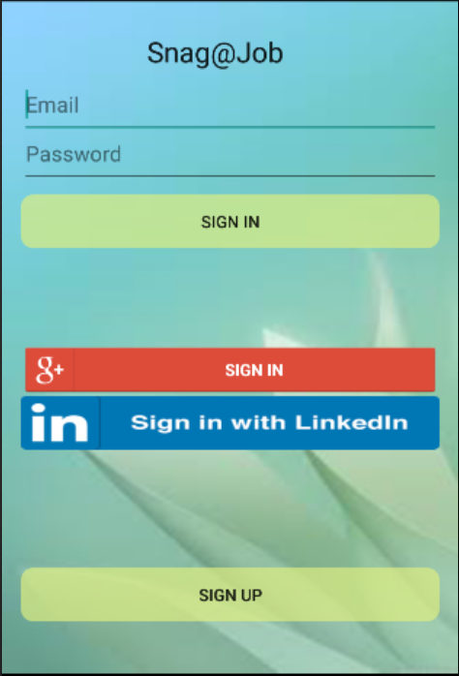

Gmail Login Screen:

A New User Can Sign into app using existing Google Account, instead of creating a new profile for Application.

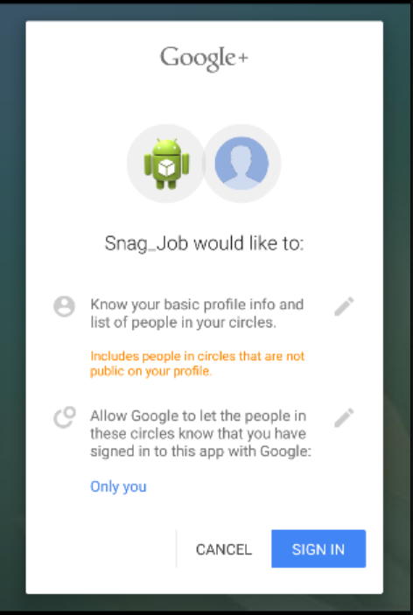

LinkedIn Login Screen

A new User Can also login with LinkedIn Sign In.



Registration Screen:

A new user can register by giving the user details.

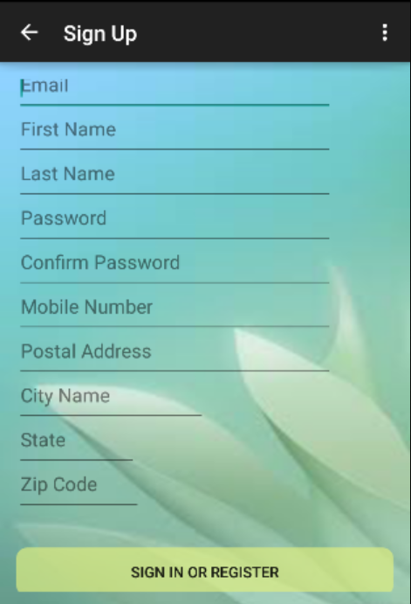

Sign in Screen:

Home Screen after successful login to the application. A user can act as an Employer or an Applicant.

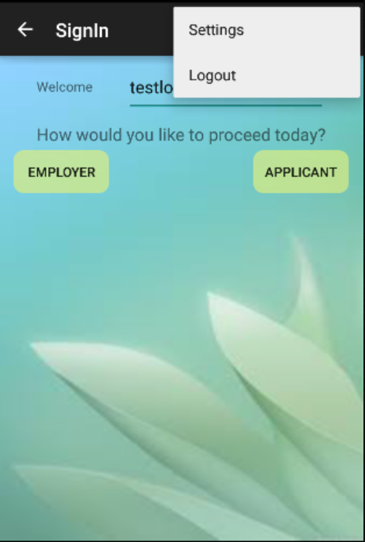

**Employer** tasks include post new jobs/modify posted jobs/view the applications for a posted job/accept or reject application.

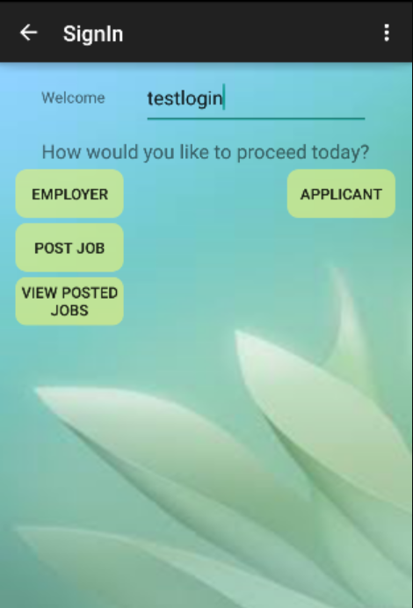 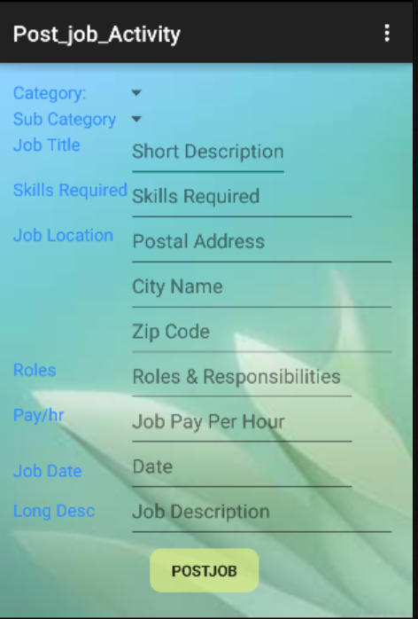

The Employer can check the list of Completed jobs(Applicant Hired)/Pending(Applicant yet to be hired) posted.

 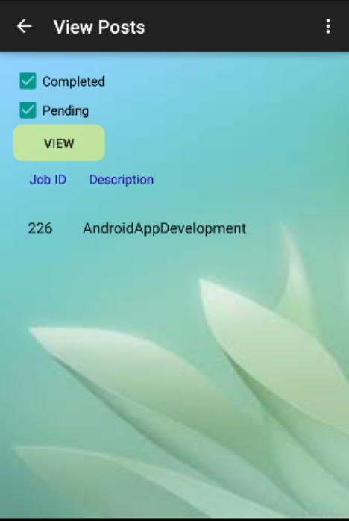

The below screen shot shows that the Employer can edit the posted jobs details and save the changes.

 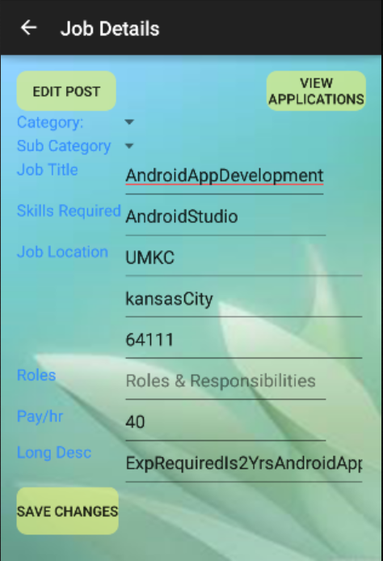

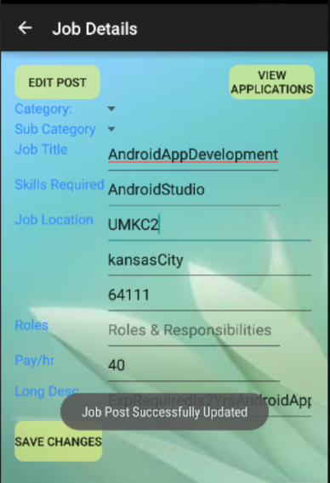 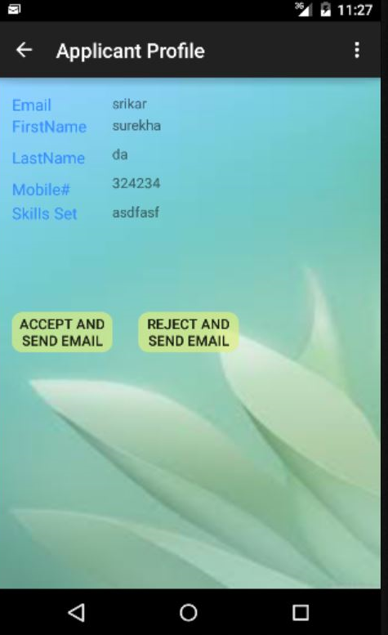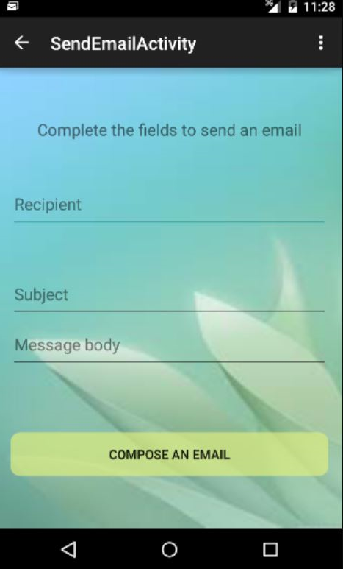 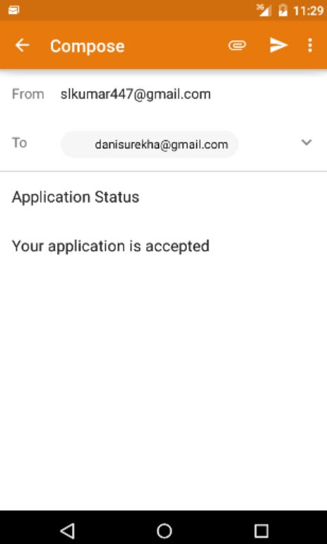

Applicant tasks include search for job/apply for job/view status of the applied job.

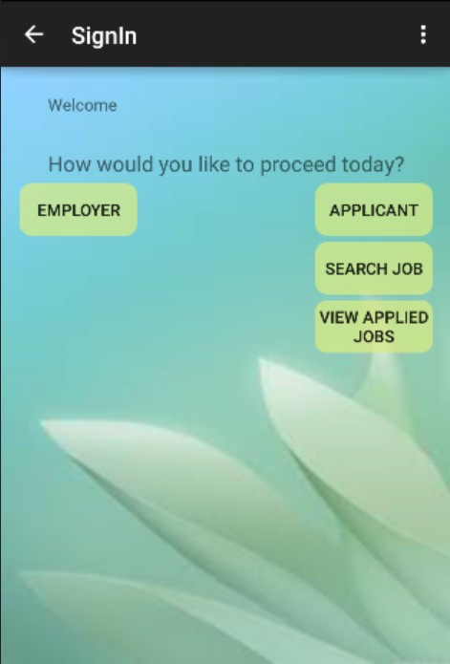 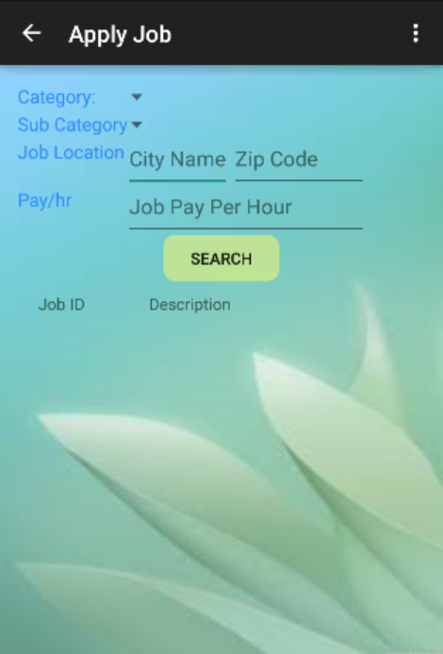

The below screens show that the Applicant can search for a job and based on the search criteria the list of available jobs is shown to the applicant from which the applicant can select any job and Apply for the job

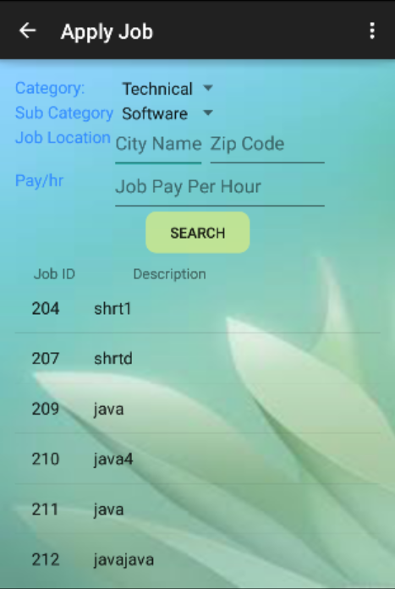 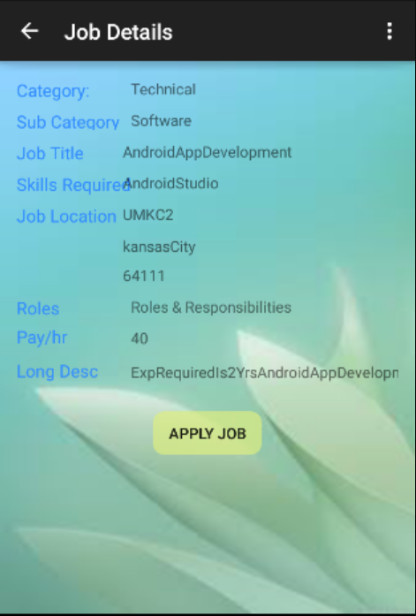

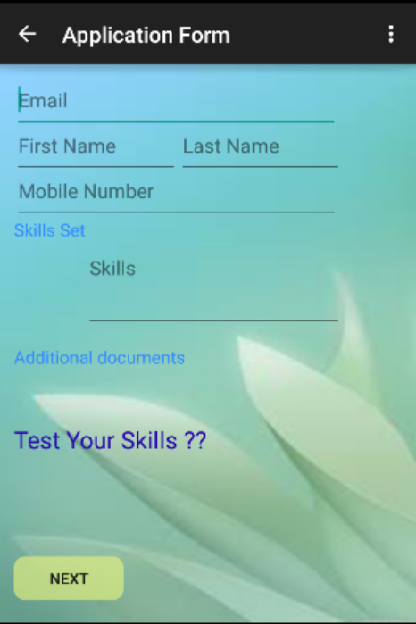

The below screen asks the applicant to fill the details and take test

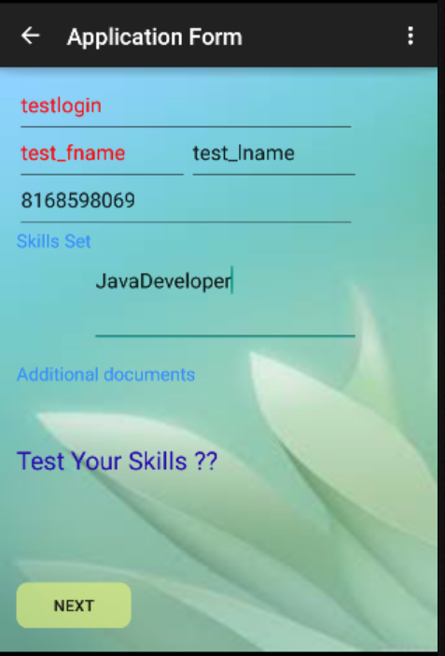

The below screen shows that the Applicant can take test and the score will be updated in the database so that the employer can select the applicant based on the test score.

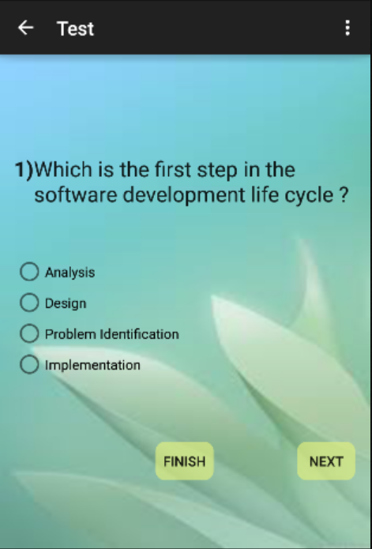 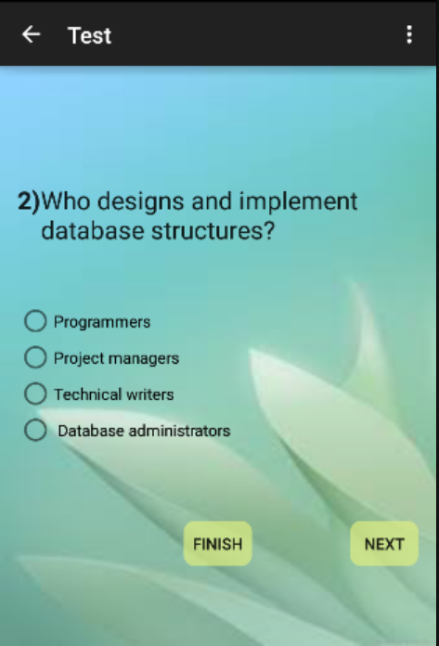

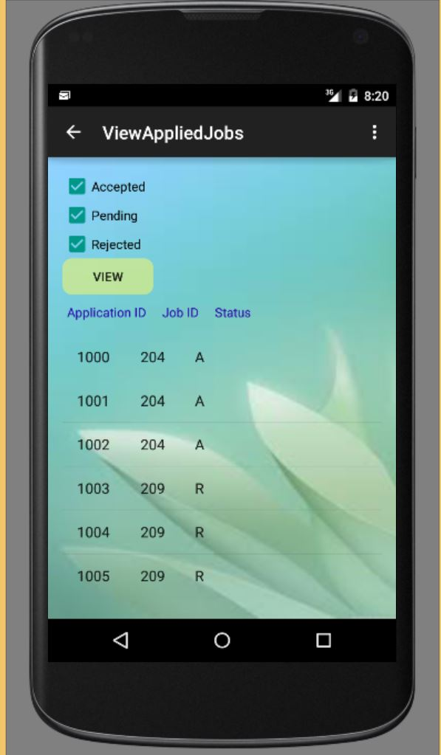The Below Screens allows the Applicant to view all the Applied Jobs and on clicking on the Application ID we can fetch all the details of job application. 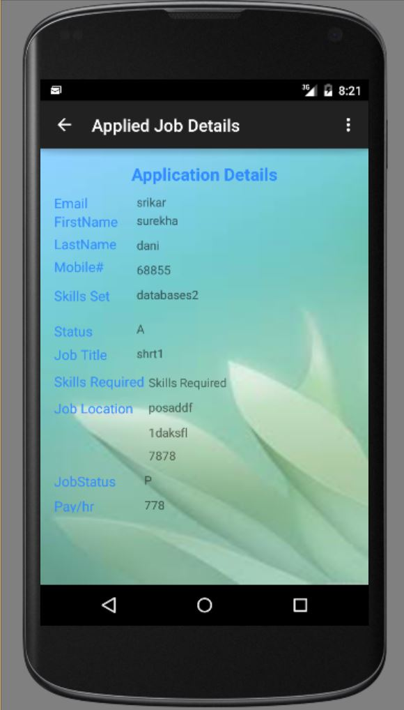

Project Management

## Work completed in Current Iteration

### Description

* Successfully deployed our web services in the remote server.
* All the Web services are successfully implemented from Android application to manage the backend data storage and retrieval.
* Successfully integrated the Google-SignIn with the Snag@Job Application
* View Posted Jobs Activity to view the list items from a Web service.
* View Applied Jobs Activity to view the list items of Applied Jobs from a Web service
* Applied Job Details Activity to list the details of Applicant’s Information using a Web service
* Edit the existing posts or view the applications for a single job to accept or reject the applications.
* Search the posted jobs by an applicant with the search Criteria View the status of Applied Jobs to the Applicant
* Apply the Posted jobs with completing the job application and the skill test for a particular Job
* View the status of Applied Jobs to the Applicant
* View the status of Applied Jobs to the Employer
* Employer can send a mail regarding the Application whether it is accepted or rejected
* Designed the activities for android application to facilitate user interface to navigate and perform the employer or applicant tasks using the Snag@Job.

### Responsibility (Task, Person)

* RetrieveAppliedJobDetails WS, RetrieveAppliedJobDetails WS Unit Testing, with Corresponding Android Layouts – Srikar Reddy Mallareddygari
* Integration of Google Maps API, RetrieveIndividualJobDetails WS Unit Testing with Corresponding Android Layouts and Performance Testing – Lavanya Kumar Somu
* RetrieveApplicationJobDetails WS, RetrieveApplicationJobDetails WS Unit Testing, Integration of Google Sign In, Session Management with Corresponding Android Layouts – Surekha Dani
* Retrieve Questions WS, Development of Questionnaire for skill Test,UpdatePostJobDetail WS Unit Testing with Corresponding Android Layouts – Sandesh Puppala

### Time taken

300 Man Hours

### Contributions (members/percentage)

Srikar Reddy Mallareddygari – 25%

Lavanya Kumar Somu - 25%

Surekha Dani - 25%

Sandesh Puppala – 25%

# Issues/Concerns

* Large android project for Mobile deployment
* Slow performance of the web service call